Implementing Inji for Verifiable Credentials with Existing PKI

Overview
Inji provides a framework for verifiable credentials while leveraging existing Public Key Infrastructure (PKI). This approach combines the trust model of traditional PKI with the user-centric, privacy-preserving benefits of verifiable credentials.

Key Components
- Issuer: Organization authorized to issue credentials (government agency, educational institution, etc.)
- Inji Certify: The component handling credential issuance and signing
- Existing PKI: The certificate authority infrastructure providing digital signatures
- Inji Wallet: Mobile application storing user credentials
- Inji Verify: The verification service used by relying parties

Implementation Strategy

1. Integration with Existing PKI
- Use existing X.509 certificates from the PKI for digital signatures
- Map the certificate hierarchy to credential trust relationships
- Implement certificate validation checks during verification

2. Credential Issuance Process
- Issuers authenticate themselves using their existing PKI certificates
- Inji Certify formats credentials according to W3C Verifiable Credentials Data Model
- Credentials are signed using the issuer's private key from the PKI
- The credential includes the issuer's certificate chain for verification

3. Wallet Implementation
- Develop Inji Wallet as a secure mobile application
- Implement secure storage for credentials with biometric protection
- Include functionality for selective disclosure of credential attributes
- Support offline credential presentation

4. Verification Process
- Inji Verify validates the digital signature using the issuer's public key
- Certificate chain is validated against trusted root certificates
- Implement revocation checking via OCSP or CRL
- Verify credential hasn't expired and meets other validity requirements
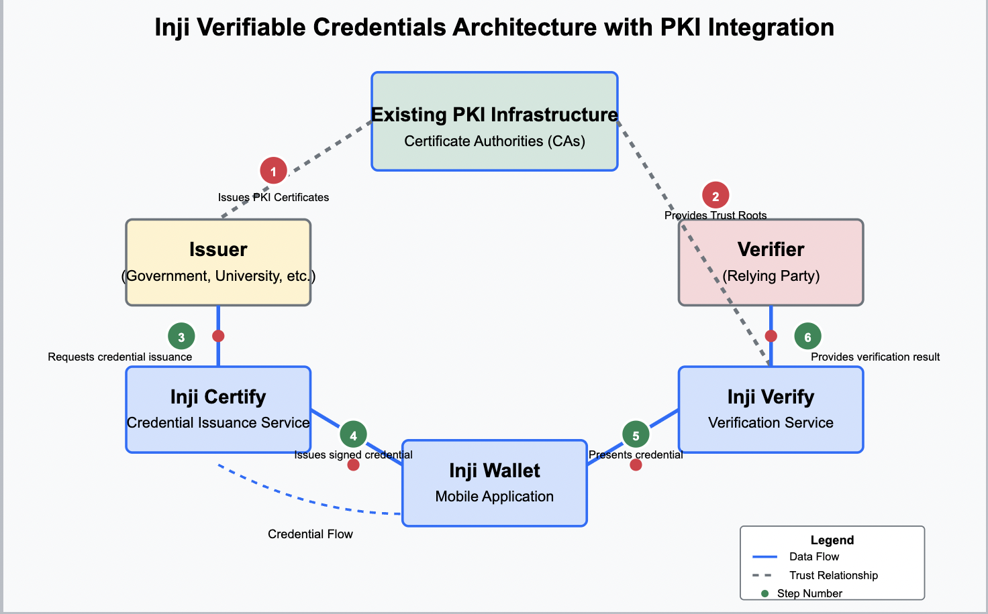

Technical Implementation Details

1. Credential Format
- Use W3C Verifiable Credentials format with JSON-LD
- Include standard credential metadata (issuer, issuance date, expiry)
- Embed the X.509 certificate or reference to it
- Structure for selective disclosure and zero-knowledge proofs

2. Signing Process
- Use standard PKI signing algorithms (RSA-PSS, ECDSA, or EdDSA)
- Implement JWS (JSON Web Signatures) for credential signatures
- Include the certificate chain for verification
- Optionally implement signature schemes that support selective disclosure

3. Verification Process
- Certificate path validation against trusted roots
- Certificate status checking (OCSP/CRL)
- Signature verification using issuer's public key
- Schema validation of the credential format
- Check for revocation of the credential itself

4. Key Security Considerations
- Protect issuer private keys in HSMs
- Implement key rotation policies
- Use secure storage for credentials in the wallet
- Employ biometric authentication for the mobile wallet
- Support credential revocation

Benefits of This Approach
- Leverages existing trust infrastructure
- No need to establish new root of trust
- Compatible with existing security practices
- Easier adoption for organizations with PKI
- Combines centralized trust with decentralized storage and user control

